Introduction to Programming & Python

📌 What is Programming? (Concepts & Importance)

🔹 1. Definition of Programming
Programming is the process of giving instructions to a computer to perform a specific task. It involves writing, testing, and debugging code in a programming language like Python, Java, or C++.

🔹 2. Why is Programming Important?
✅ Automation – Reduces manual work by automating repetitive tasks
✅ Data Processing – Used in data analysis, AI, and machine learning
✅ Software Development – Builds applications (web, mobile, desktop)
✅ Problem-Solving – Helps in logical thinking and structuring solutions
✅ IoT & Robotics – Used in smart devices and robotics development

🔹 3. How Does a Computer Understand Programs?
Computers only understand binary (0s and 1s). Programming languages act as a bridge between humans and machines.
- High-level languages (Python, Java, C++) → Easy for humans to write
- Low-level languages (Assembly, Machine Code) → Close to hardware

🆚 Difference Between Coding & Programming
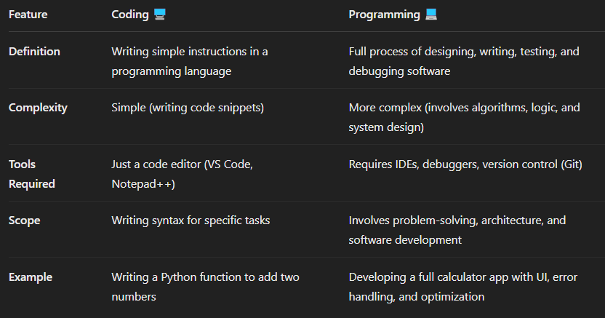

📝 Key Takeaways
✔ Coding is a part of Programming
✔ Programming includes problem-solving, designing, and debugging
✔ A good programmer knows both coding & software development concepts

Types of Programming Paradigms
Programming languages follow different paradigms (styles of programming) based on how they solve problems. Here are the major types:

1️⃣ Procedural Programming
🔹 Definition: Uses step-by-step instructions (procedures) to solve problems.
🔹 Example Languages: C, Pascal, Python (supports procedural style)
🔹 Key Features:
✅ Follows a top-down approach
✅ Uses functions (procedures) to divide code
✅ Easy to read and understand
🔹 Where is it Used?
- Small programs
- Simple automation scripts

2️⃣ Object-Oriented Programming (OOP)
🔹 Definition: Organizes code into objects (real-world entities) with properties and methods.
🔹 Example Languages: Python, Java, C++, C#
🔹 Key Features:
✅ Uses classes and objects
✅ Supports Encapsulation, Inheritance, Polymorphism, Abstraction
✅ Best for scalable and reusable code
🔹 Example in Python:
🔹 Where is it Used?
- Large applications
- Web development
- Game development

3️⃣ Functional Programming
🔹 Definition: Treats computation as the evaluation of mathematical functions and avoids changing state.
🔹 Example Languages: Python, Haskell, Lisp, Scala
🔹 Key Features:
✅ Uses pure functions (no side effects)
✅ Supports higher-order functions (map(), filter(), reduce())
✅ Good for parallel computing
🔹 Where is it Used?
- Data processing (Pandas, PySpark)
- AI and ML applications

Functional Programming (FP) vs Object-Oriented Programming (OOP) – Technical Differences
1️⃣ State Management
- OOP → Uses objects that store data (stateful). Example: A BankAccount class with a balance that updates.
- FP → No stored state, only pure functions. Example: A function that calculates interest without modifying the balance.
2️⃣ Mutability vs Immutability
- OOP → Objects are mutable (can be modified).
- FP → Data is immutable; changes return new data instead of modifying existing ones.
3️⃣ Concurrency & Parallelism
- OOP → Shared states can lead to race conditions (requires locks & synchronization).
- FP → No shared state, making it better for parallel processing (e.g., Spark, Dask).
4️⃣ Code Structure
- OOP → Organizes code using classes and objects with methods.
- FP → Uses pure functions that take input and return output without side effects.
5️⃣ Reusability & Testing
- OOP → Testing is harder due to dependencies between objects.
- FP → Easier to test as functions are independent and don’t depend on object state.

When to Use What?
✅ Use OOP for applications with long-lived objects (e.g., web apps, games).
✅ Use FP for data transformations, parallel computing, and big data processing (e.g., Pandas, PySpark).

How is FP Different from OOP?
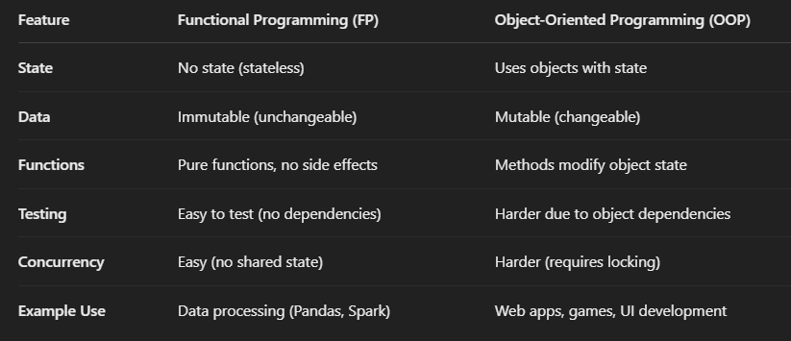

Conclusion
✅ Use FP for data transformations, analytics, machine learning, and parallel computing.
✅ Use OOP for building applications, user interfaces, and complex systems.

✅ Here are some popular languages, platforms, and tools developed using Python:

🔹 1. YouTube (Initial Prototype)
- The early version of YouTube was developed using Python.
- Even today, Python is used in parts of YouTube's backend for automation and data.

🔹 2. Instagram
- Instagram's backend is heavily powered by Python + Django.
- It handles billions of users and photos using Python.

🔹 3. Dropbox
- Dropbox's desktop client and server-side code are written in Python.
- Even the founder, Guido van Rossum (creator of Python), worked at Dropbox.

🔹 4. Reddit
- Originally written in Lisp, then moved to Python for scalability and ease of development.

🔹 5. BitTorrent
- The peer-to-peer file sharing protocol BitTorrent was initially created using Python.

🔹 6. OpenStack
- A popular cloud computing platform used by many enterprises — mostly written in Python.

🔹 7. Blender (Scripting Language)
- The 3D modeling and animation software Blender uses Python for scripting and automation.

🔹 8. Ansible
- A powerful infrastructure automation tool, written in Python.

🔹 9. TensorFlow (Some parts)
- While TensorFlow is mainly in C++, it has a Python API, and many training scripts are written in Python.

🔹 10. Pip, Flask, Django, Pandas, NumPy, etc.
- All these Python frameworks and libraries are, of course, developed in Python.

✅ Languages Developed in Python (Extended List)

1) Hy
- What Is It? A Lisp dialect that compiles to Python’s Abstract Syntax Tree (AST).
- Key Point: You can mix Lisp code with Python libraries, making it easy to use Lisp features (macros, s-expressions) alongside the entire Python ecosystem.

2) Coconut
- What Is It? A functional programming superset of Python.
- Key Point: Coconut adds pattern matching, lazy lists, and other functional features, then compiles down to standard Python code.
- Usage: Great if you want Haskell-like features in a Python-based project.

3) MyHDL
- What Is It? A hardware description language (HDL) built in Python.
- Key Point: Instead of using VHDL or Verilog, you can describe hardware logic in Python (MyHDL). It translates your Python code into Verilog or VHDL for actual circuit synthesis.

Why Are They Built in Python?
- Easy to Parse & Transform: Python has powerful libraries for parsing, AST manipulation, and code generation.
- Large Ecosystem: They can reuse the entire Python ecosystem (e.g., packaging, tooling, libraries).
- Rapid Prototyping: Python’s readability and flexibility make it ideal for building new languages or DSLs quickly.

✅ Popular Frameworks Developed in Python

🕸️ Web Development
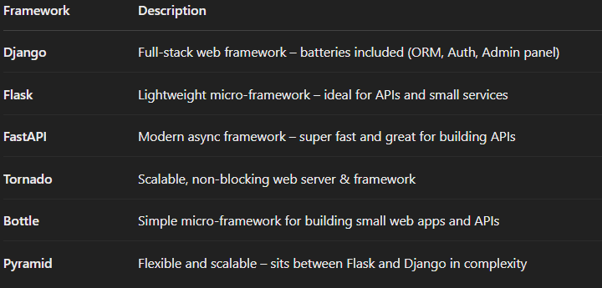

📊 Data Science / Machine Learning

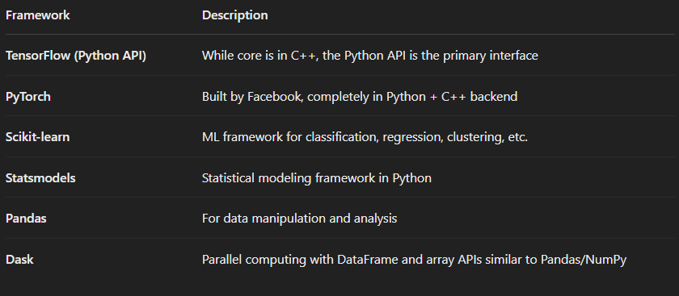

📦 Web Scraping & Automation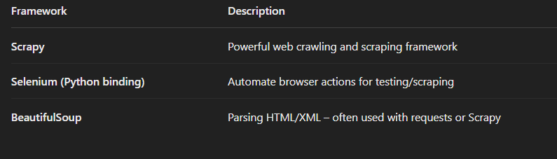

💻 GUI Development
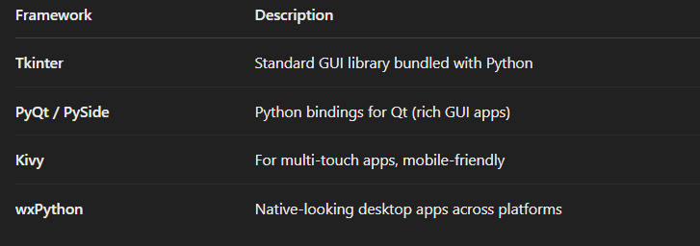

☁️ Cloud, DevOps, Automation
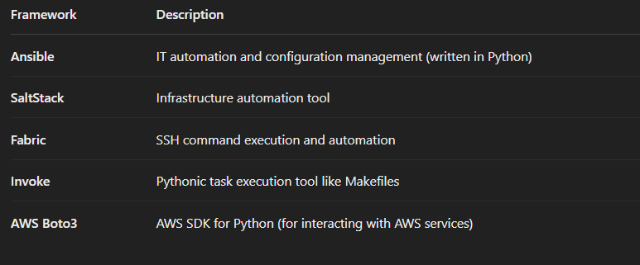

🧪 Testing
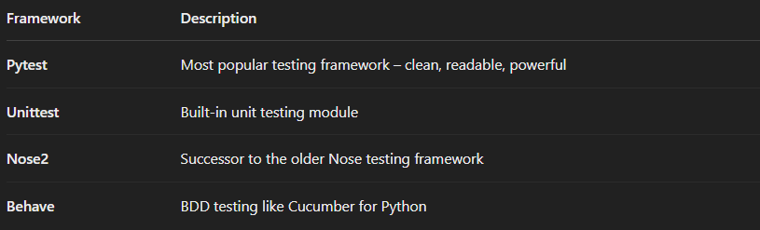

🛠️ Other Interesting Frameworks

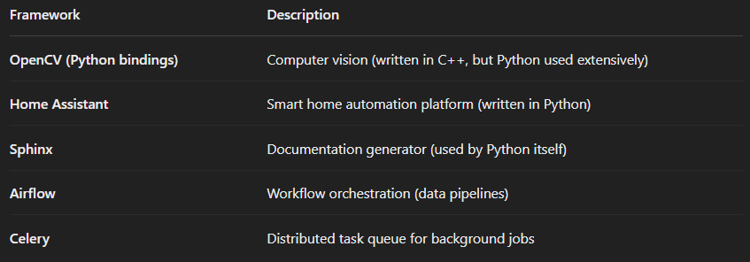

Python has frameworks in:
- ✅ Web Dev (Django, Flask, FastAPI)
- ✅ Data Science (PyTorch, Scikit-learn)
- ✅ Automation (Ansible, Airflow)
- ✅ Desktop GUI (Tkinter, PyQt)
- ✅ Testing (Pytest, Unittest)
- ✅ Scraping (Scrapy, BeautifulSoup)

📝 Python Software Foundation License (PSFL)

🔹 What is PSFL?
- The Python Software Foundation License is a free and open-source license, approved by both:
  - OSI (Open Source Initiative)
  - FSF (Free Software Foundation)

🔹 Key Points of the PSFL: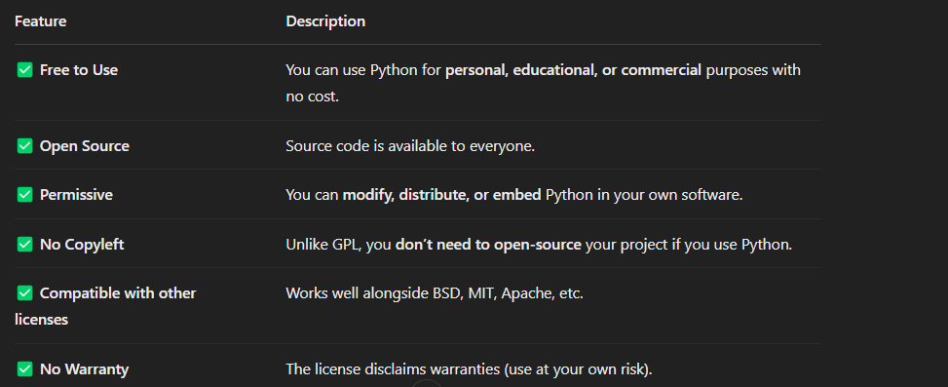

🔹 Which version of Python uses this license?
- Since Python 2.1, the language is licensed under the PSFL.
- Earlier versions (before 2.1) had a license similar to the CNRI license.

🔐 Is Python truly “Free”?
YES – Free as in:
- Free Speech (freedom to use, change, distribute)
- Free Beer (no cost)

🚀 Real-World Implication:
You can:
- Use Python to build apps (even commercial ones)
- Modify the source code of Python itself
- Embed Python in your product
- Distribute your tools without worrying about licensing restrictions

📜 Python History in Short

🔹 1991 – Python was born
- Created by Guido van Rossum in the Netherlands.
- First version (Python 0.9.0) was released on February 20, 1991.
- Inspired by ABC language and named after Monty Python’s Flying Circus (not the snake! 🐍😂)

🐍 Python Compilation Process with PVM
Python is an interpreted language, but it still involves a compilation step — just not like C or Java.
Let’s go step-by-step:

🔷 Step 1: Writing Code
You write code in a .py file (example: hello.py)
print("Hello, World!")

🔷 Step 2: Compilation to Bytecode (.pyc)
- When you run your Python script:
  - Python first compiles it to an intermediate code called bytecode.
  - This bytecode is saved as a .pyc file in the __pycache__ folder.

hello.py 👉 Compiled to hello.cpython-311.pyc

✅ Bytecode is:
- A low-level, platform-independent set of instructions.
- Not human-readable.
- Faster to execute than re-parsing .py files every time.

🔷 Step 3: Execution by PVM (Python Virtual Machine)
- The PVM reads the .pyc bytecode and executes it line by line.
- It handles:
  - Memory management
  - Variable storage
  - Function calls
  - Object creation
  - Exception handling

✅ The PVM is the actual runtime engine that runs your Python code.
🔷 Visualization:
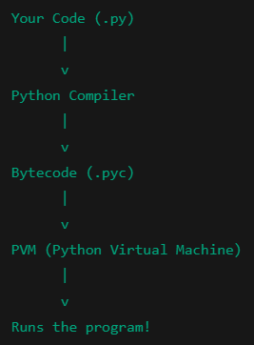
💡 Key Points:

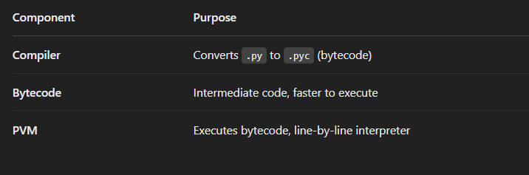

❓ Why Not Directly to Machine Code?
Because:
- Python is platform-independent (write once, run anywhere).
- Using bytecode + PVM allows for flexibility and easier debugging.
- Machine code would tie Python to a specific OS/CPU.

✅ Summary:
- Python compiles .py → .pyc (bytecode)
- PVM reads and executes bytecode
- This makes Python interpreted, but with an internal compilation step

🔁 Contrast with a Compiled Language (like C):
In C:
- Entire .c code is compiled into machine code (.exe) before running
- Then you run the executable
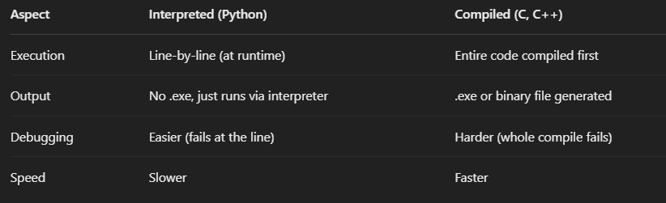
💡 Why Bytecode?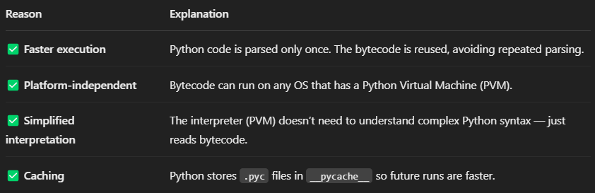

🧠 Final Analogy:
- Python file (.py) = Your original recipe
- Bytecode (.pyc) = The pre-prepared dish
- PVM = The waiter that serves it to the customer (computer) line by line

🌍 What Does Platform-Independent Mean?
A language is platform-independent if you can write code once and run it on any operating system (Windows, Mac, Linux, etc.) without changing it.

🐍 How Python Achieves Platform Independence:

🔹 1. Python Code → Compiled to Bytecode (.pyc)
- When you run a .py file, Python compiles it into bytecode — a platform-neutral intermediate format.
- This bytecode is not specific to Windows or Linux — it’s a common format.

🔹 2. Bytecode is Executed by PVM (Python Virtual Machine)
- The PVM is platform-specific, but the bytecode is the same on all platforms.
- Think of the PVM as the waiter who understands your dish (bytecode) no matter the country (OS).

📦 Example:
You write a script:
python
print("Hello World")
You can:
- Run it on Windows using Python installed on Windows → compiles to bytecode → executed by Windows PVM
- Run the same script on Mac or Linux → same bytecode → executed by Mac/Linux PVM
You don’t need to change your code 👌

🧠 Real-World Analogy:
Think of bytecode as a “universal recipe” written in symbols.
Every country (OS) has its own chef (PVM) who knows how to read it and cook it.
So the same recipe can be cooked anywhere — just by using the local chef.
✅ Summary:
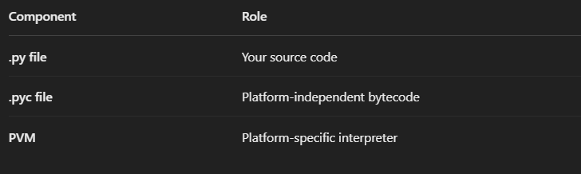

So, the magic lies in:
- Bytecode being universal
- PVM being customized per platform
That’s how Python = Write once, run anywhere ✅

✅ How to Install Python on Windows (Official Method)

🔹 Step 1: Download Python
- Go to the official Python website:
👉 https://www.python.org/downloads/
- Click on the latest version for Windows
Example: "Download Python 3.12.x"

🔹 Step 2: Run the Installer
- Double-click the downloaded .exe file.
- 🟡 Important! Before clicking "Install Now": ✅ Check the box that says:
🔲 Add Python 3.x to PATH
This allows you to run Python from anywhere in your terminal.
- Click "Install Now"

🔹 Step 3: Wait for Installation
- Python will install along with pip (Python package manager).
- Once done, click “Close”.

🔹 Step 4: Verify Installation
- Open Command Prompt (cmd)
- Type:
python --version

➡️ You should see:
Python 3.12.x

- Also try:
pip --version

➡️ Confirms that pip is also installed.

🔹 (Optional) Open IDLE or VS Code
- You can search for IDLE (Python’s built-in editor) in the Start menu
- Or install VS Code for a better coding experience

🎯 You’re Ready to Go!
Now you can start writing .py files and run them from:
- IDLE
- VS Code
- Command Line

❗ What If You Already Installed Python Without Adding to PATH?
No worries! You can add it manually:

🔧 How to Add Python to PATH Manually (Windows)
Find Python installation path
Usually it's in:
C:\Users\<YourName>\AppData\Local\Programs\Python\Python3x\
- Copy the full path, for example:
C:\Users\Gowtham\AppData\Local\Programs\Python\Python312\
- Now do this:
  - Search "Environment Variables" in Start
  - Click “Edit the system environment variables”
  - In the window, click “Environment Variables…”
  - In System variables, find Path → click Edit
  - Click New, then paste the Python path
C:\Users\<YourName>\AppData\Local\Programs\Python\Python3x\Scripts\

- Click OK → OK → OK
- Restart your Command Prompt

🧪 Test it:

python --version
pip --version

If it works → you're good to go! 🚀

Step 1: Download PyCharm Community Edition
- Visit the Official Download Page:
  - Navigate to the PyCharm Download page.
- Choose Your Operating System:
  - The page will automatically detect your OS (Windows, macOS, or Linux). If not, select the appropriate tab for your system.
- Select the Community Edition:
  - You'll see two options: Professional and Community. Under the Community section, click the Download button.

Step 2: Install PyCharm Community Edition
For Windows:
- Run the Installer:
  - Locate the downloaded .exe file (usually in your 'Downloads' folder) and double-click to run it.
- Follow the Installation Wizard:
  - Welcome Screen: Click Next.
  - Choose Install Location: You can use the default location or specify a different folder. Click Next.
  - Installation Options:
    - Create Desktop Shortcut: (Optional) Check this box if you want a shortcut on your desktop.
    - Update PATH Variable: (Recommended) Check this to add PyCharm to your system PATH.
    - Create Associations: (Optional) Check this to associate .py files with PyCharm.
  - Click Next and then Install.
- Complete Installation:
  - Once the installation is complete, you can choose to run PyCharm immediately or finish the setup.
For macOS:
- Open the Disk Image:
  - Locate the downloaded .dmg file and double-click to open it.
- Install PyCharm:
  - Drag the PyCharm icon into the Applications folder.
- Launch PyCharm:
  - Navigate to your Applications folder and double-click the PyCharm icon to start the application.

For Linux:
- Extract the Tarball:
  - Open your terminal and navigate to the directory containing the downloaded .tar.gz file.
Run the following command to extract:
tar -xzf pycharm-community-*.tar.gz -C /desired/installation/path/

- Run PyCharm:
Navigate to the bin directory inside the extracted folder:
cd /desired/installation/path/pycharm-community-*/bin

  - Run PyCharm using:
./pycharm.sh

Step 3: Initial Configuration
- Import Settings:
  - If you've previously used PyCharm and have settings to import, choose the appropriate option. Otherwise, select Do not import settings.
- Customize UI (Optional):
  - You can choose a theme (Light or Dark) and configure other UI settings as per your preference.
- Install Plugins (Optional):
  - PyCharm may suggest installing additional plugins based on your development needs. You can choose to install them now or later.
- Create or Open a Project:
  - Once the initial setup is complete, you can create a new project or open an existing one to start coding.

About the Author
Gowtham SB is a Data Engineering expert, educator, and content creator with a passion for big data technologies, as well as cloud and Gen AI . With years of experience in the field, he has worked extensively with cloud platforms, distributed systems, and data pipelines, helping professionals and aspiring engineers master the art of data engineering.
Beyond his technical expertise, Gowtham is a renowned mentor and speaker, sharing his insights through engaging content on YouTube and LinkedIn. He has built one of the largest Tamil Data Engineering communities, guiding thousands of learners to excel in their careers.
Through his deep industry knowledge and hands-on approach, Gowtham continues to bridge the gap between learning and real-world implementation, empowering individuals to build scalable, high-performance data solutions.
𝐒𝐨𝐜𝐢𝐚𝐥𝐬
🎥𝐘𝐨𝐮𝐓𝐮𝐛𝐞 - https://www.youtube.com/@dataengineeringvideos
📸𝐈𝐧𝐬𝐭𝐚𝐠𝐫𝐚𝐦 - https://instagram.com/dataengineeringtamil
📸𝐈𝐧𝐬𝐭𝐚𝐠𝐫𝐚𝐦 - https://instagram.com/thedatatech.in
🤝𝐂𝐨𝐧𝐧𝐞𝐜𝐭 𝐟𝐨𝐫 𝟏:𝟏 - https://topmate.io/dataengineering/
💼𝐋𝐢𝐧𝐤𝐞𝐝𝐈𝐧 - https://www.linkedin.com/in/sbgowtham/
🌐𝐖𝐞𝐛𝐬𝐢𝐭𝐞 - https://codewithgowtham.blogspot.com
💻𝐆𝐢𝐭𝐇𝐮𝐛 - http://github.com/Gowthamdataengineer
💬𝐖𝐡𝐚𝐭𝐬 𝐀𝐩𝐩 - https://lnkd.in/g5JrHw8q
📧𝐄𝐦𝐚𝐢𝐥 - atozknowledge.com@gmail.com
📱𝐀𝐥𝐥 𝐌𝐲 𝐒𝐨𝐜𝐢𝐚𝐥𝐬 - https://lnkd.in/gf8k3aCH

